**THUA THIEN HUE CENTER OF INFORMATION TECHNOLOGY**

**HUE-APTECH COMPUTER EDUCATION CENTER**



## aptech_ww_lon

**PROJECT**

**COURSE CPISM – ACCP i10**

**Project name:**

**Airlines Reservation Website**

**Faculty:** VoThanh Son **Group** : unknown

**Class** : CP201605L **Members** :1. Le Hai Nam

2. Nguyen Thai Bao



**Hue, [10/2016]**

**CERTIFICATE**

This is to certify that

Group:

Members:

Mr: Le Hai Nam

Mr: Nguyen Thai Bao

Has successfully designed, developed Airline Reservation System

Submitted by: VoThanh Son

Date: ………………………

Signed by: …………………

## Table of contents

[**1. DEFINITION OF THE PROBLEM 4**](#_Toc447548555)

[**2. CUSTOMER REQUIREMENT SPECIFICATION 10**](#_Toc447548556)

[**3. PROJECT PLAN 13**](#_Toc447548557)

[**4. USECASE DIAGRAM 15**](#_Toc447548558)

[**5. FLOWCHART DIAGRAM 16**](#_Toc447548559)

[**6. DATA FLOW DIAGRAM 19**](#_Toc447548560)

[**7. ENTITY RELATIONSHIP DIAGRAM 21**](#_Toc447548561)

[**8. TABLE DESGIN 22**](#_Toc447548562)

[**9. PROGRAMDESIGN 29**](#_Toc447548563)

[**10. GUI DESIGN 35**](#_Toc447548564)

[**11. TASK SHEETS 45**](#_Toc447548565)

[**12. FINAL CHECKLIST 47**](#_Toc447548566)

**A**[**PPENDIX – Install guide 48**](#_Toc447548567)

[**COMMENTS OF FACULTY 53**](#_Toc447548568)

## DEFINITION OF THE PROBLEM

* 1. **Problem**

Gone are the days when people used to spend all their lives in the same city and touring was a world for rich people only. Now, with the technological advancements, cheaper flight, and ever increasing awareness towards other states and countries, the world has become a smaller place. So to reduce stress on desk-reservation systems, reservation online is the best way.

The project is to design an airline reservation system that will take care of all the reservation related issues and will give the result in quick time.

* 1. **Solutions**

The Airline Reservation System (ARS) is a software application to assist an airline with transactions related to making ticket reservations, which includes blocking, reserving, canceling and rescheduling tickets.

Some of the features are:

* The ARS will provide the following types of easy-to-use, interactive, and intuitive graphical and telephonic interfaces. Maintenance of profile details of the users, and retrievals as and when required.
* The ARS will provide an easy-to-use, intuitive Graphical User Interface (GUI) as part of the Clerk/Administrator’s working desktop environment.
* The ARS will also provide an interactive GUI, on the World Wide Web for the general customers.
* The above two ARS interfaces shall help provide the following functionalities to the users - access to the ARS to check the flight schedule, availability of seats, ticket price and to block, reserve, cancel, and reschedule tickets.

As the whole project is based on the logical perspective of an ideal Airline Reservation System structure, the physical implementation has no fixed rules, thus implementing the concept little difficult.

* 1. **Function**

The Airline Reservation system is supposed to be able to automatically solve all the basic ticket and booking related problems between users and the reservation system. It has been modularized into below modules:

1. Customer registration / log in
2. Flight availability checking
3. Flight reservation
4. Making confirmation/cancellation
5. View/update customer’s profile and booking history, ticket status…
6. Query flight details
7. Reschedule flight
   * 1. **Customer registration / log in:**

|  |  |
| --- | --- |
| **Description** | Provides suitable form for guests and registered users to log in or sign up for the system |
| **Input** | Customer profile (including Name, address, email, phone number, sex, birthday, credit card number, username, password…) or login account info if registered |
| **Process** | Inserts new record to User database or signs user in if he has already registered |
| **Output** | New user logged in to the system |

* + 1. **Flight availability checking:**

|  |  |
| --- | --- |
| **Description** | Looks up the database to find the suitable flights, routes, transit spots,… and display them. Suggests user with a different route if the selected route is not available. |
| **Input** | Original city, destination city, departure date, return date (if applied), passenger configuration, class |
| **Process** | Uses the user inputs to search for available routes using path finding algorithm, prepares related details and shows them to the customer |
| **Output** | The appropriate routes and flights for customers, ready for booking/blocking |

* + 1. **Flight reservation**

|  |  |
| --- | --- |
| **Description** | Processes reservation by purchase or block a ticket chosen in function 1.3.2 |
| **Input** | Ticket information, block or purchase request |
| **Process** | Validates and updates database to reserve the ticket, charges the customer if needed. |
| **Output** | Result of the process, updated database |

* + 1. **Making confirmation/cancellation**

|  |  |
| --- | --- |
| **Description** | Charges user for a blocked ticket or cancels a confirmed/blocked ticket |
| **Input** | Blocking number or confirmation number, action request |
| **Process** | Charges the user for his blocked ticket, refunds canceled ticket if they’ve been purchased, then update the database for available seats, user’s skymiles… |
| **Output** | Result of the process, updated database |

* + 1. **View/update customer’s profile and booking history, ticket status…**

|  |  |
| --- | --- |
| **Description** | Enables the user to access his profile and history, update some of the information and provides a user interface for ticket related functions (reschedule, cancellation, confirmation,…) |
| **Input** | Action request, login information |
| **Process** | Show user’s profile, booking history, ticket-related function buttons |
| **Output** | The information users requested for |

* + 1. **Flight query**

|  |  |
| --- | --- |
| **Description** | Allows any user (registered or non-registered) to access the details about the arrival and departure times of a flight by requesting the user to input the flight number and date. |
| **Input** | Flight number and date |
| **Process** | The system accesses database-schedule and presents the time of arrival and departure. |
| **Output** | Time of departure and arrival of a flight |

* + 1. **Reschedule**

|  |  |
| --- | --- |
| **Description** | Allows user to change their confirmed ticket’s configuration |
| **Input** | Ticket information and all of the updated information |
| **Process** | Updates the ticket information and charges or refunds user if there’s any change in pricing. |
| **Output** | Updated ticket information |

1. **CUSTOMER REQUIREMENT SPECIFICATION**
   1. **User account**

A user who has traveled by the airline earlier would have been given a user id and a password. He would have his personal information stored in the database. The system shall require a user to register, in order to carry out any transactions with it except for checking the availability of tickets. A guest can only check the availability of tickets and cannot block or buy tickets.

* 1. **Checking Availability**

The system should be able to perform route and flight query and return appropriate results for user’s input conditions such as original city, destination city, departure date and time, return date and time, class,… It should also be smart enough to suggest a customer for an alternative route or city if his choices are unavailable. When the choices are made, it would calculate all the fee and price for the ticket then show it to the customer, with the policies attached.

* 1. **Making reservation**

The customers should be able to block the ticket if the departure date and the system date is more than 2 weeks. They can also buy the ticket if they want at any time. The system would send the customers an email in order to remind them to buy the ticket 3 weeks before departure date if they blocked it. Any blocked ticket that has not been confirmed 2 weeks before departure date will be cancelled.

* 1. **Reschedule:**

The system shall present the user with an option to re-schedule his travel party’s trip. In order to do this, the system first logs on the user and requests his confirmation number. It will not allow a user to reschedule a blocked ticket but only a confirmed ticket. Using this, it queries database-reservation and presents the details of the trip to the user, including but not limited to origin city, destination city, date of departure and date of arrival (in case the trip is a round trip).

* 1. **Cancellation:**

The system shall also give the user an option to cancel a confirmed ticket or a blocked ticket. If the ticket has been confirmed, the customer will be charged for the cancellation fee.

* 1. **Update profile:**

The system shall enable the user to update his profile at any time. Changes can be made in fields including but not limited to address, phone number and preferred credit card number.

* 1. **View ticket status:**

The system shall allow a user to view all information about his trip. After logging him on, it asks for his blocking number or his confirmation number. It accesses database-reservation and retrieves the details of the trip and presents them to the user in a convenient format, including any last minute changes to the flight timings etc. Such changes will be highlighted.

* 1. **Query flight details:**

The system shall allow any user (registered or non registered) to access the details about the arrival and departure times of a flight by requesting the user to input the flight number and date. The system accesses database-schedule and presents the time of arrival and departure.

## PROJECT PLAN

* 1. **Project details**
* **Name of the project:** The Airline Reservation System
* **Date of Project Plan**
  + Start day: **28-Sep-2016**
  + Finish day: **29-Oct-2016**
* **Project Vision/ Objectives**(Define the project vision/objective as stated by the client)
  + Making ticket reservations
  + Blocking, reserving, canceling and rescheduling tickets.
  1. **Quality plan**
* **Review activities** (review meeting participants, frequency)

|  |  |  |  |
| --- | --- | --- | --- |
| **NUM** | **Time process** | **Work** | **The implementation** |
| 1 | 28/09/2016🡪 04/10/2016 | Problem definition, CRS, Project plan | Team |
| 2 | 05/10/2016🡪 12/10/2016 | DesignDFD database Design Form | Team |
| 3 | 13/10/2016🡪20/10/2016 | Coding | Team |
| 4 | 20/10/2016🡪28/10/2016 | Check some existing problem. | Team |

* **Testing activities**
  + Testing activities have processed after modify, update**.**
  + Thanks comment for the teacher, our friends.
* **Backup and recovery strategies**
  + After each test stage, documents have updated in devices: USD, laptop, PC in the center to avoid data loss by the objective circumstances.

## USECASE DIAGRAM



## FLOWCHART DIAGRAM

Flowchart diagram 1: Connect to SQL Server

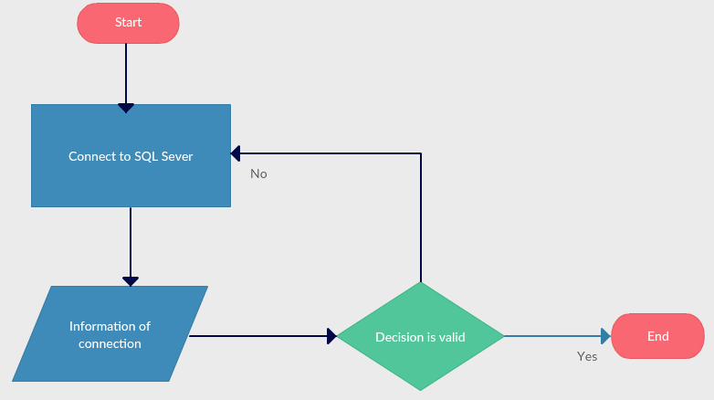

Flowchart diagram 2: Login

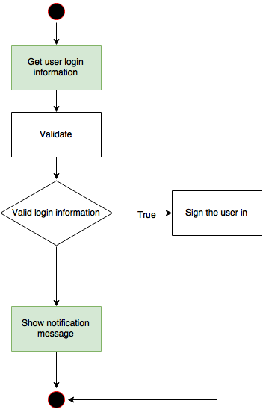

Flowchart diagram 3: Cancel a ticket

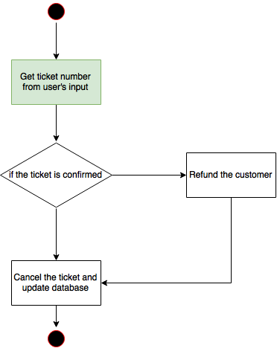

Flowchart diagram 4: Block-Buy a ticket

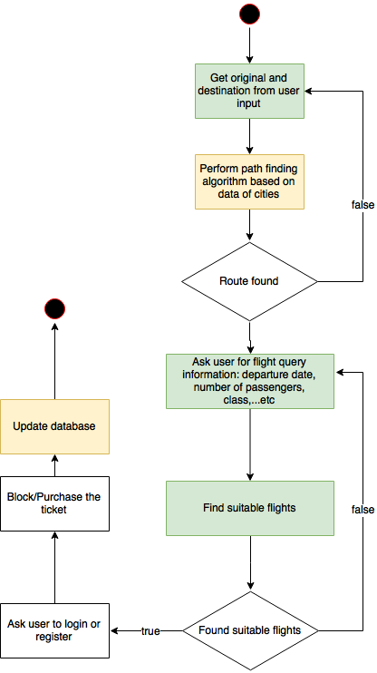

## DATA FLOW DIAGRAM

DFD Lever 0: Context diagram



DFD Level 1-1: Configuration SQL Server

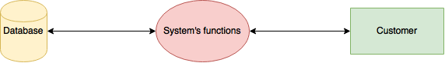

DFD Level 2.1: Sign in and sign up

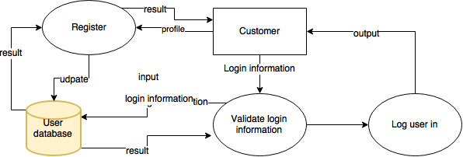

DFD Level 2.2: Book a ticket

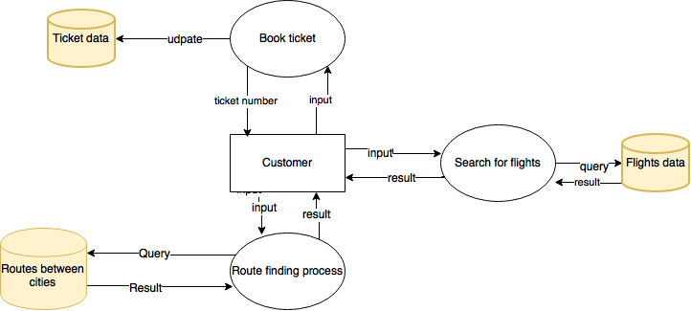

## ENTITY RELATIONSHIP DIAGRAM

## https://gyazo.com/d3ae2e23c9ee2e20327d03f5eef05fe9.png

## TABLE DESIGN

|  |  |  |  |  |  |  |  |
| --- | --- | --- | --- | --- | --- | --- | --- |
| **Table:City** | | | | | | | |
| **Field name** | **Data Type** | | **Null** | | **Key** | | **Description** |
| CityID | varchar(3) | | Not | | PK | | Store the ID of City |
| CityName | nvarchar(50) | | Yes | |  | | Store the full name of City |
| InService | bit | | Not | |  | | Store available flight in this City |
| **Table: Class** | | | | | | | |
| **Field name** | | **Data Type** | **Null** | **Key** | | **Description** | |
| ClassID | | Int | Yes | PK | | Store the ID of Class | |
| ClassName | | nvarchar(50) | Yes |  | | Store the full name of Class | |

|  |  |  |  |  |  |  |  |  |  |  |
| --- | --- | --- | --- | --- | --- | --- | --- | --- | --- | --- |
| **Table: Flight** | | | | | | | | | | |
| **Field name** | | **Data Type** | | **Null** | | | **Key** | | | **Description** |
| FlightNo | | varchar(10) | | Not | | | PK | | | Store the Flight Number |
| CurrentPrice | | decimal(18, 2) | | Not | | |  | | | Store the Price |
| DepartureTime | | datetime | | Yes | | |  | | | Store the departure time |
| RouteID | | int | | Yes | | |  | | | Store the route ID |
| Duration | | float | | Yes | | |  | | | Store the duration to finished |
| **Table: Route** | | | | | | | | | | |
| **Field name** | **Data Type** | | **Null** | | **Key** | | | | **Description** | |
| RouteID | Int | | Not | | PK | | | | Store the Route ID | |
| OriginalCityID | varchar(3) | | Not | |  | | | | Store the original city ID | |
| DestinationCityID | varchar(3) | | Not | |  | | | | Store the destination city ID | |
| Distance | float | | Not | |  | | | | Store the distance between two cities | |
| InService | bit | | Not | |  | | | | Store the value route available or not | |
| **Table: Seat** | | | | | | | | | | |
| **Field name** | **Data Type** | | **Null** | | | **Key** | | **Description** | | |
| ClassID | int | | Yes | | | FK | | Store the class id | | |
| SeatID | varchar(4) | | Not | | | PK | | Store the seat id | | |
| **Table: TakenSeat** | | | | | | | | | | |
| **Field name** | **Data Type** | | **Null** | | | **Key** | | **Description** | | |
| SeatID | varchar(4) | | Not | | | FK | | Store the seat id | | |
| FlightNo | varchar(10) | | Not | | | FK | | Store the flight number | | |
| TicketNo | varchar(10) | | Yes | | |  | | Store the ticket number | | |

|  |  |  |  |  |
| --- | --- | --- | --- | --- |
| **Table: Ticket** | | | | |
| **Field name** | **Data Type** | **Null** | **Key** | **Description** |
| TicketNo | varchar(10) | Not | PK | Store the ticket number |
| UserID | varchar(50) | Not | FK | Store the user id |
| ConfirmationNo | varchar(10) | Yes | FK | Store the confirmation code |
| BlockNo | varchar(10) | Yes |  | Store the block value |
| CancellationNo | varchar(10) | Yes |  | Store the cancellation value |
| Price | decimal(18, 2) |  |  | Store the price of ticket |
| CreatedDate | date |  |  | Store the date created this ticket |
| NumberOfAdults | int | Yes |  | Store the number of adult |
| NumberOfChildren | int | Yes |  | Store the number of Children |
| NumberOfSeniorCitizens | int | Yes |  | Store the number of senior citizens |
| Status | int |  |  | Store the status |

|  |  |  |  |  |  |
| --- | --- | --- | --- | --- | --- |
| **Table: Ticket\_Flight** | | | | | |
| **Field name** | **Data Type** | **Null** | **Key** | **Description** | |
| TicketNo | varchar(10) | Not | FK | Store the ticket number | |
| FlightNo | varchar(10) | Not | FK | Store the flight number | |
| SequenceNo | int | Not | FK | Store the sequence number of the flight | |
| IsReturn | bit | Not |  | Determines if the flight is a returning one | |
| **Table:User** | | | | | |
| **Field name** | **Data Type** | **Null** | **Key** | | **Description** |
| UserID | varchar(50) | Not | PK | | Store the UserId of the User |
| Password | varchar(50) | Not |  | | Store the Password of the user |
| FirstName | nvarchar(50) | Not |  | | Store the first name |
| LastName | nvarchar(50) | Not |  | | Store the last name |
| Email | varchar(50) | Not |  | | Store the email |
| PhoneNumber | varchar(50) | Not |  | | Store the phone number of the user |
| Sex | bit | Not |  | | Store the sex of the user |
| CreditcardNumber | varchar(20) | Yes |  | | Store the credit card number of the user |
| DateOfBirth | date | Not |  | | Store the birthdate of the user |

## PROGRAMDESIGN

## GUI DESIGNhttps://gyazo.com/3a3af34b74d4b878419fb306be11c831.jpg

Home Step 1

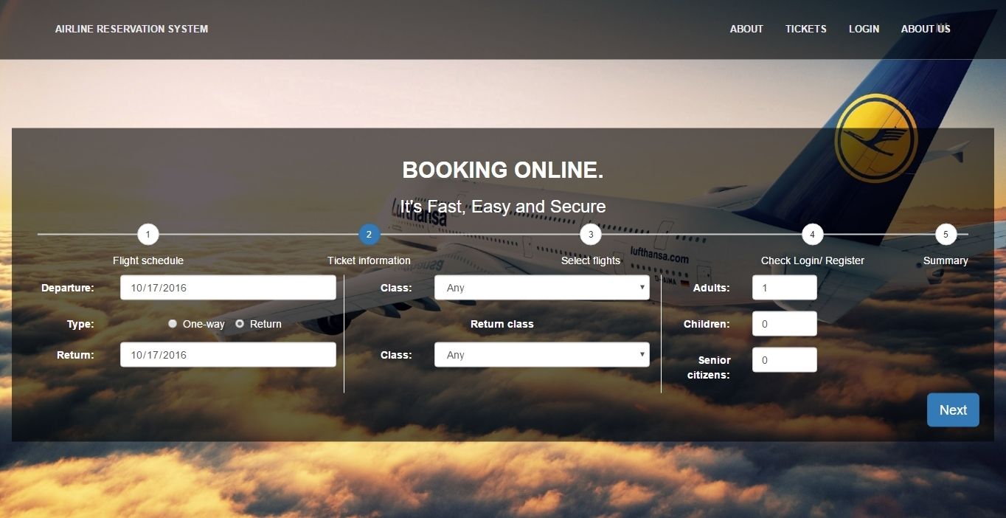  
Home Step 2

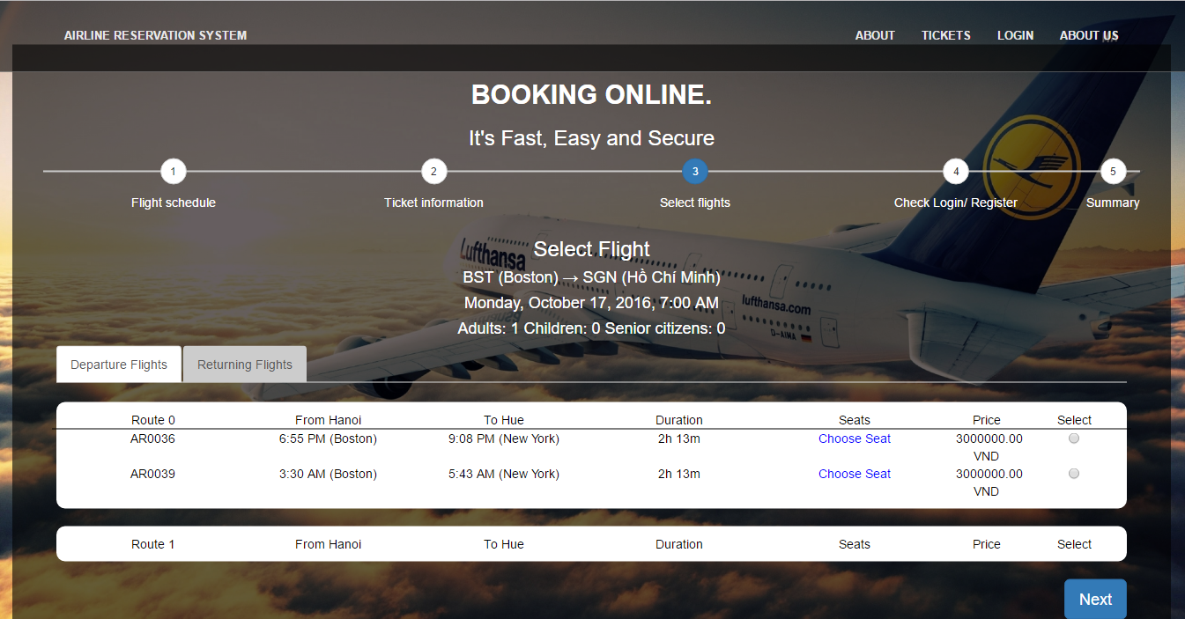  
Home Step 3.1

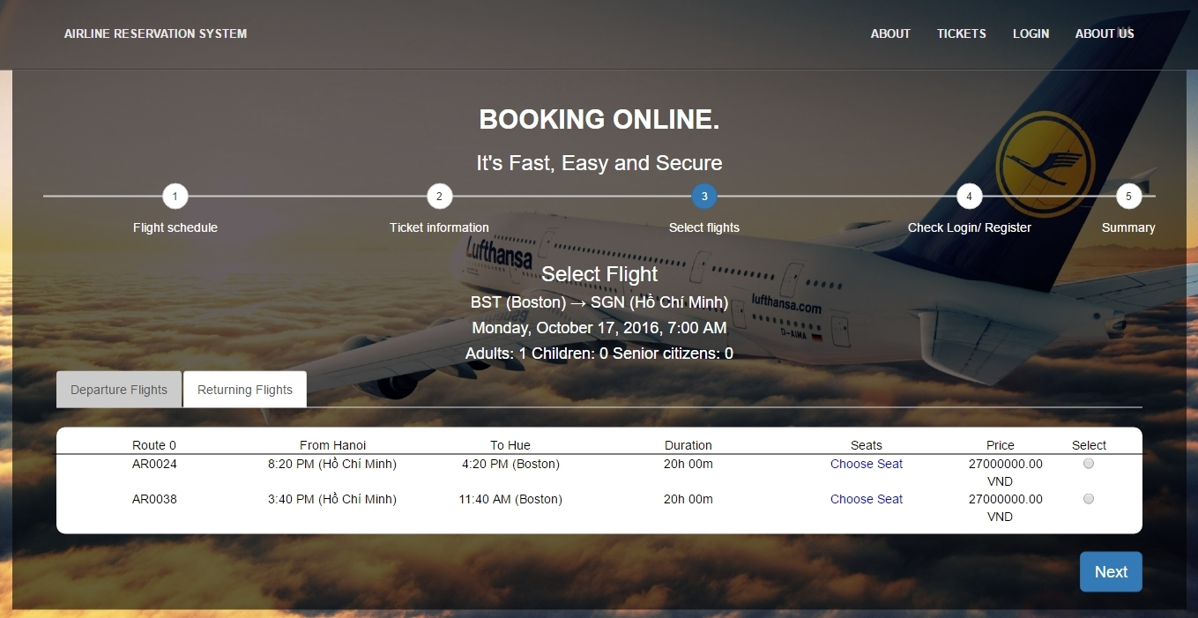

Home Step 3.2

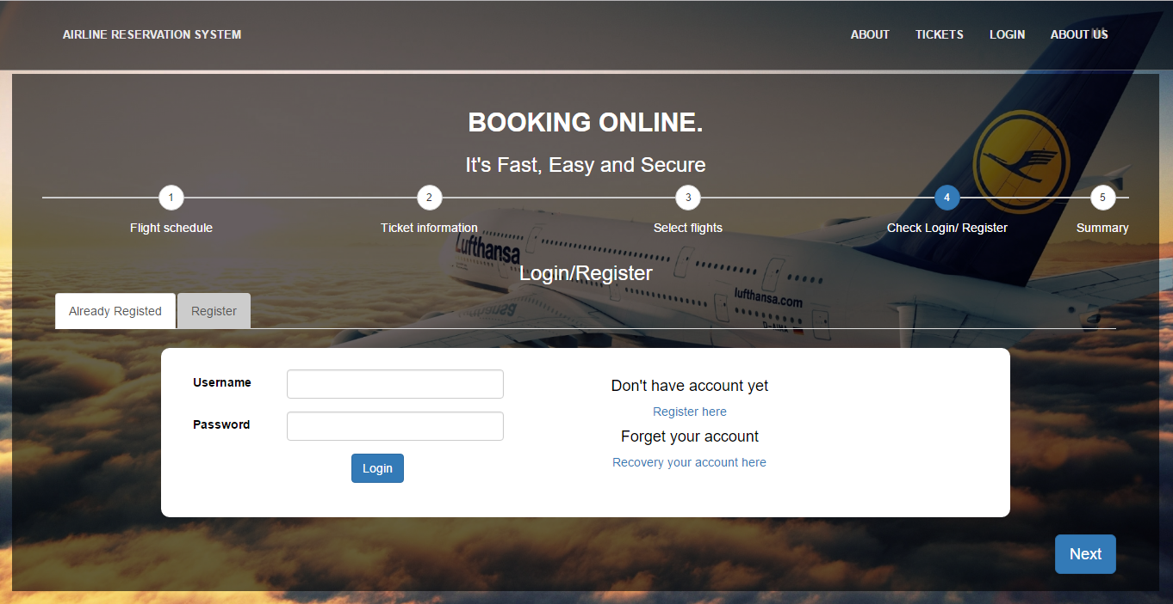

Home Step 4.1

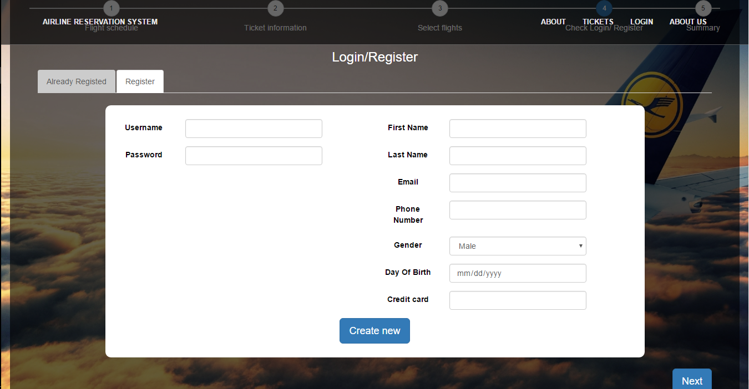

Home Step 4.2

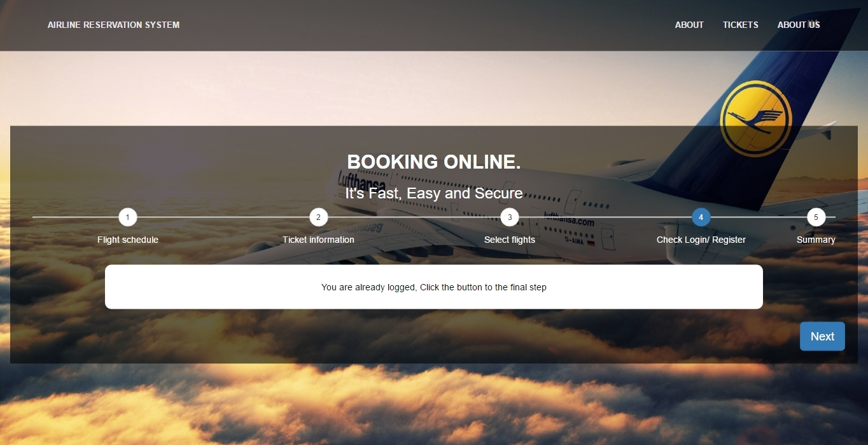

Home Step 4.3

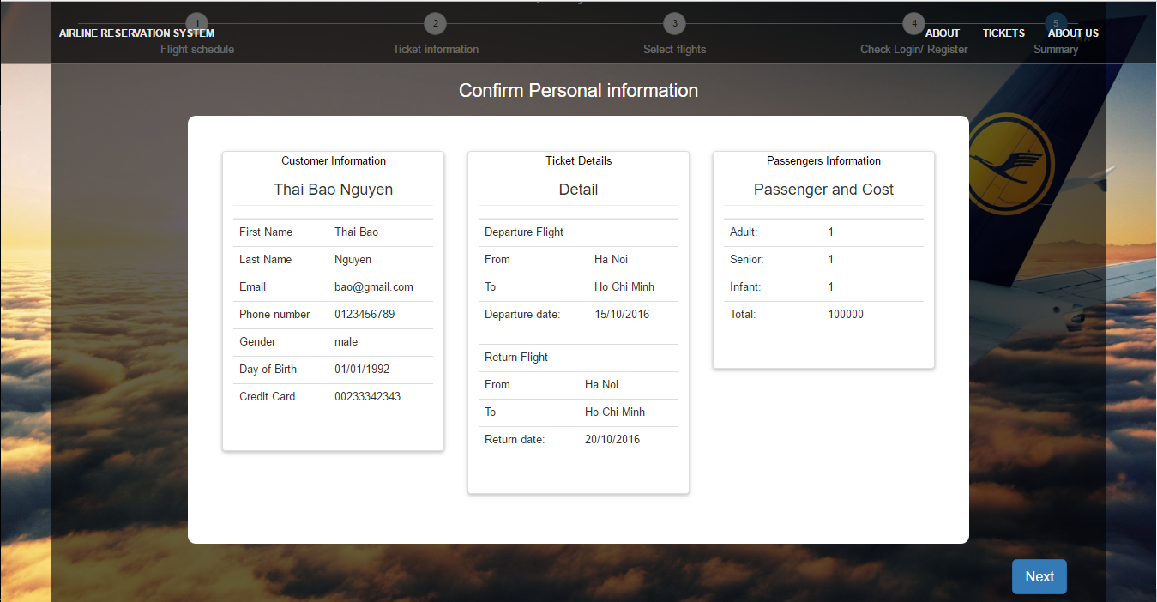

Home Step 5

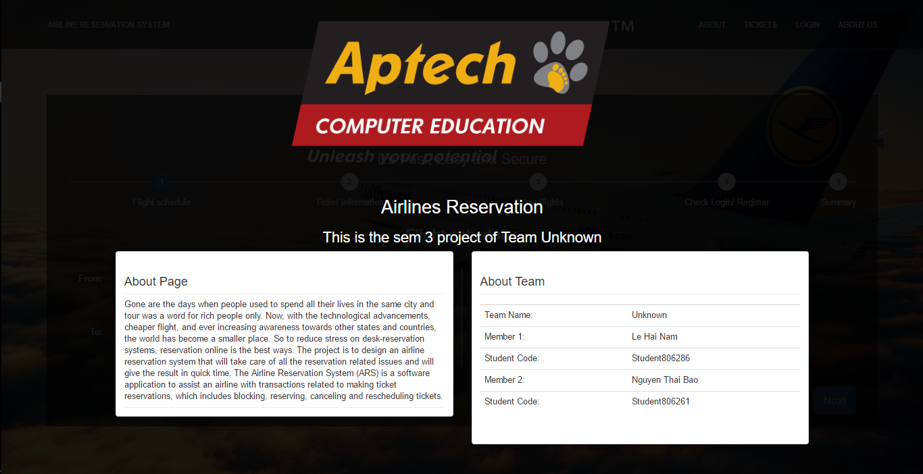

About us

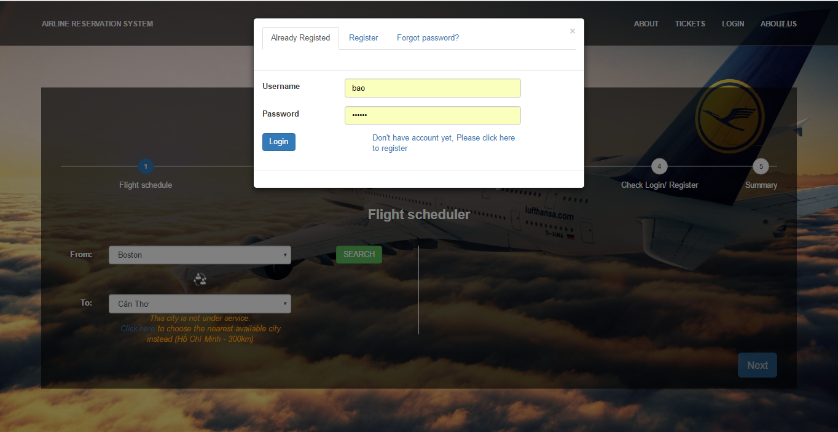

Login Page 1: Login

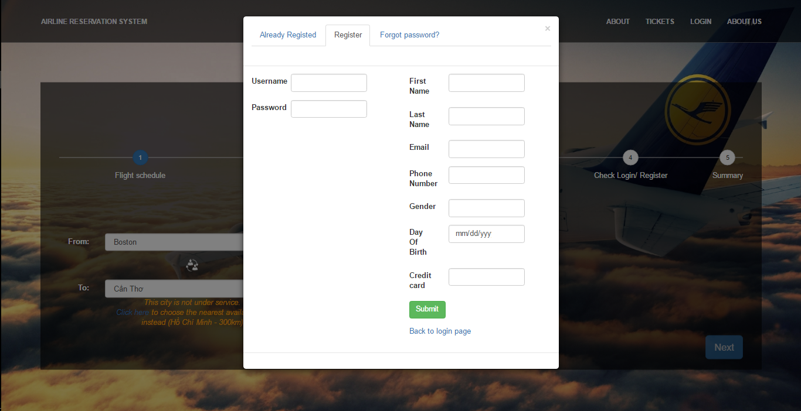

Login Page 2: Register

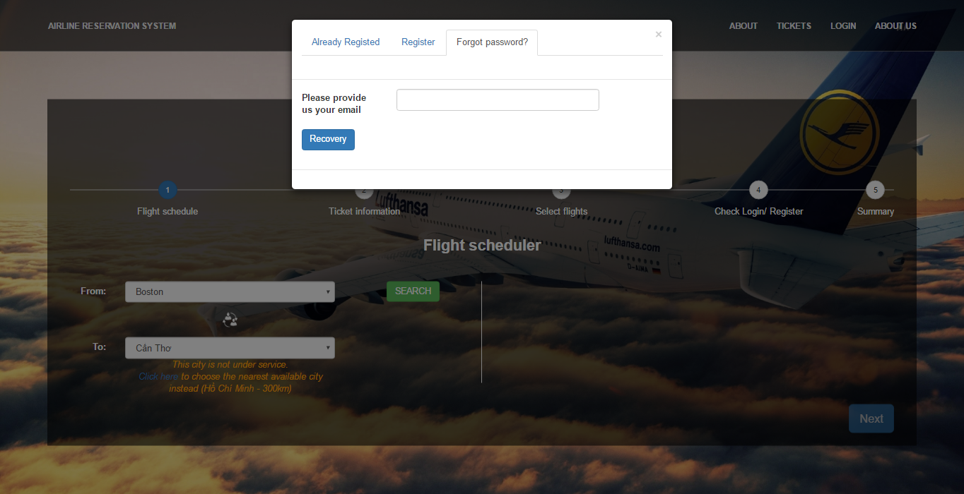

Login Page 3: Recovery Password

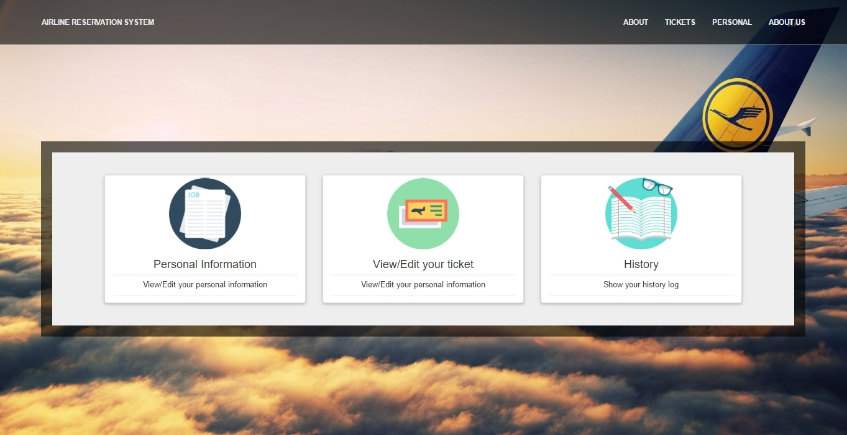

Personal Page 1: Index

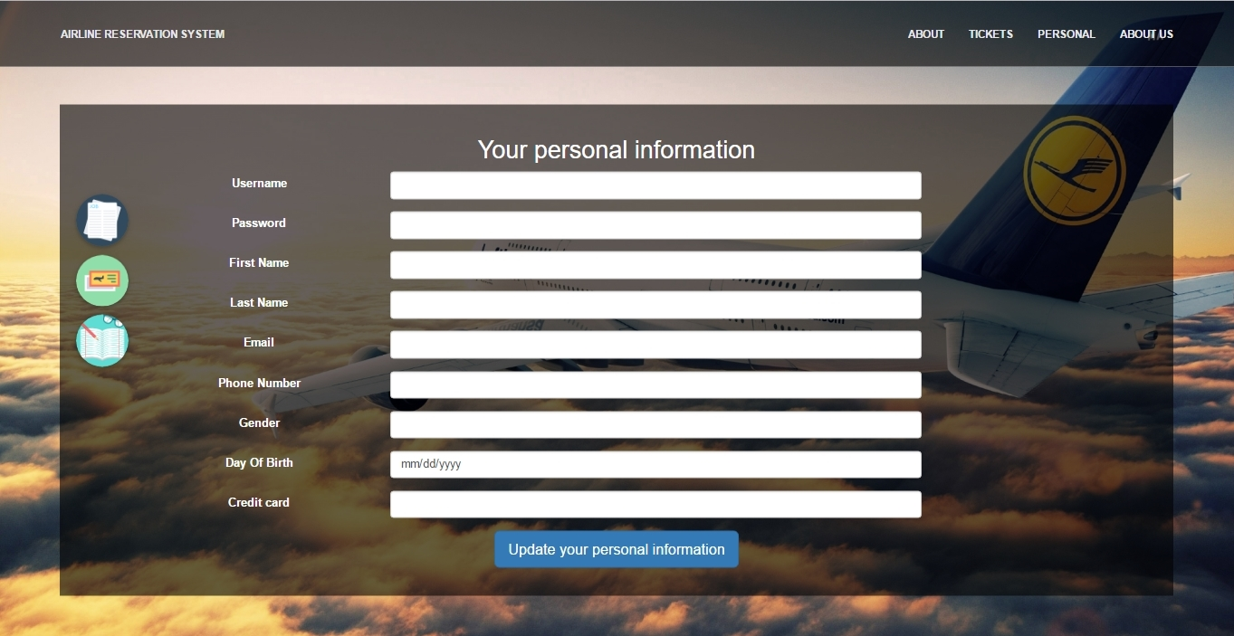

Personal Page 2: Personal information Page

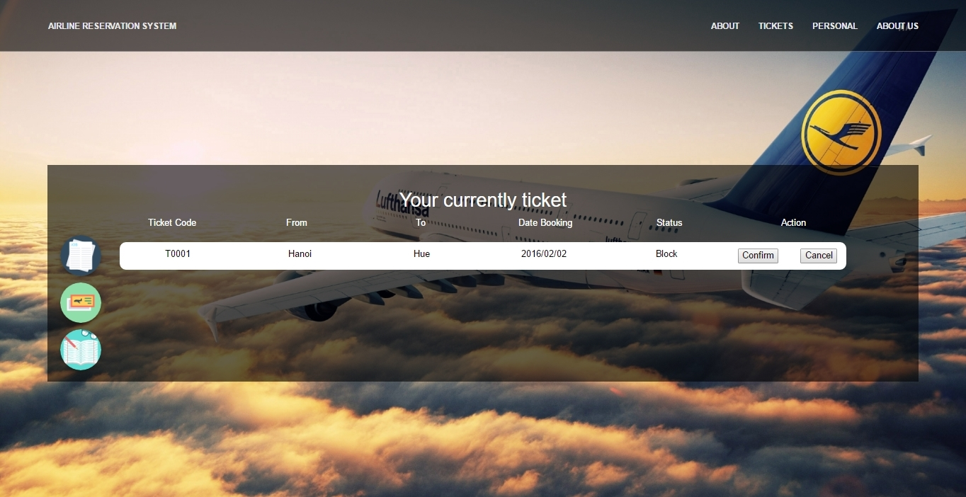

Personal Page 3: Currently Ticket

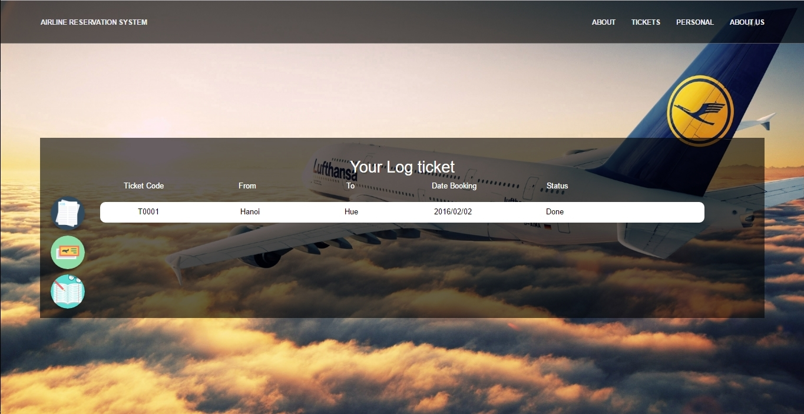

Personal Page 4: Ticket Log

## TASK SHEETS

|  |  |  |  |  |  |  |  |
| --- | --- | --- | --- | --- | --- | --- | --- |
| **Project Ref. No.:** | | **Project**  **title** | **Activity Plan Prepared by :** | **Date of Preparation of Activity Plan :** | | | |
| **Sr.**  **No.** | **Task** | **Actual Start Date** | **Actual Days** | **Team Member Names** | **Status** |
| 1 | Problem Definition | The Airplanes Reservation |  |  |  | Team |  |
| 2 | Customer Requirements Specification |  |  |  | Team |  |
| 3 | Architecture  &Design of the Project |  |  |  | Team |  |
| 4 | Data Flow  Diagram |  |  |  | Bao |  |
| 5 | Entity Relationship (ER) Diagram |  |  |  | Nam |  |
| 6 | Database Design/Structure |  |  |  | Nam |  |
| 7 | Design  Snapshot |  |  |  | Bao |  |
| 8 | Design form |  |  |  |  | Bao |  |
| 9 | Build package Data, object, utilities |  |  |  | Nam |  |
| 10 | Build package gui |  |  |  | Team |  |
| 11 | Write help document, guide setup system document |  |  |  | Team |  |
| 12 | Testing |  |  |  | Team |  |

## FINAL CHECKLIST

|  |  |
| --- | --- |
| **Aspect tested** | **Result** (yes/no) |
| Is the problem define correctly deduced from the project abstract | NO |
| All relevant documents have been done | NO |
| Are all program codes working? | NO |
| Are the codes working as per specifications? | NO |

|  |  |
| --- | --- |
| **Testing Parameter** | **Result** (yes/no) |
| Fields in forms should be not null | NO |
| All numeric fields have a default value of 0 | NO |

## 

## APPENDIX – Install guide

The default account is “***admin***” and password is “***123456***”, this one has the role as “***administrator***”, and another role “**user**” has an account with username “**user**” and password “**123456**”.

## COMMENTS OF FACULTY